**PROJECT OVERVIEW:**

**Smart Ride Analytics System** **is a ride-booking database solution that efficiently manages users, drivers, vehicles, rides, payments, and feedback. It provides real-time insights into ride statistics, revenue generation, and service quality.**

**DATABASE SCHEMA:**

**The database will consist of the following tables**

1. **Users**
   * **User_id (Primary_Key)**
   * **Name**
   * **Email**
   * **Phone_Number**
   * **Registration_Date**
   * **Location**
2. **Drivers**
   * + **Driver_id (Primary_Key)**
     + **Name**
     + **Vehicle_Type**
     + **License_No**
     + **Rating**
     + **Status**
3. **Rides**
   * **Ride_id (Primary_Key)**
   * **User_id (Foreign_Key)**
   * **Driver_id (Foreign_Key)**
   * **Pickup_Location**
   * **Dropoff_Location**
   * **Ride_Status**
   * **Ride_Date**
   * **Fare**
4. **Payments**
   * + **Payment_id (Primary_Key)**
     + **Ride_id (Foreign_Key)**
     + **Payment_Method**
     + **Amount**
     + **Payment_Date**
5. **Vehicle_Details**

* **Vehicle_id (Primary_Key)**
* **Driver_id (Foreign_Key)**
* **Vehicle_Type**
* **Vehicle_No**
* **Model**
* **Year**

1. **Feedback**

* **Feedback_id (Primary_Key)**
* **Ride_id (Foreign_Key)**
* **User_id (Foreign_Key)**
* **Rating**
* **Comments**
* **Feedback_Date**

**TABLE CREATION: Using SQL statements to create a table**

**DDL (Data Definition Language):**

**Table 1:**

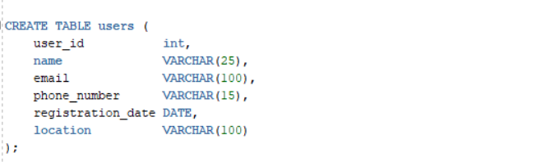

**(Similar create table queries for other tables)**

**DATA INSERTION:**

**DML (Data Manipulation Language):**

**Inserting sample data in Users table**



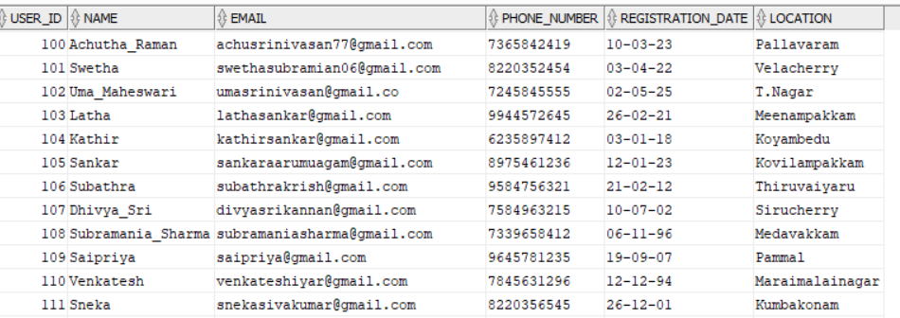

**Inserting data into Drivers table:**



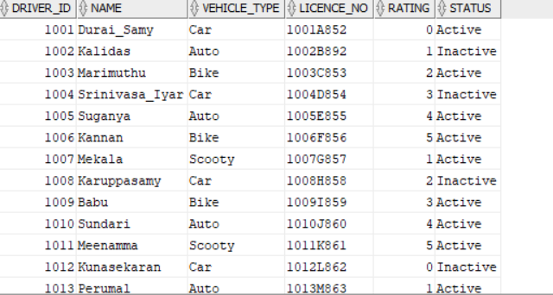

**Inserting data into Rides table:**



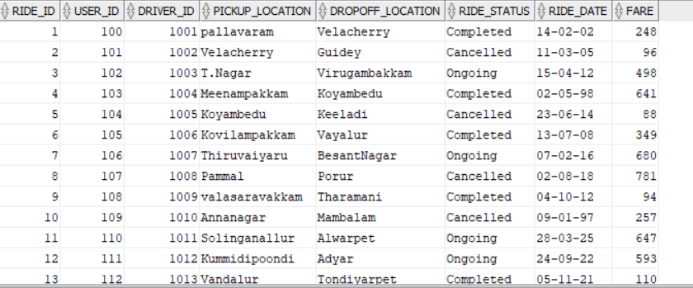

**Inserting data into Payments table:**



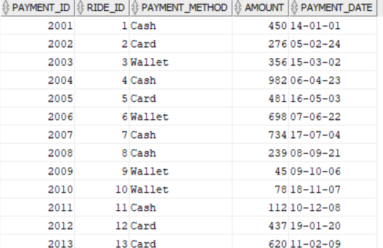

**Inserting data into Vehicle_Details table:**



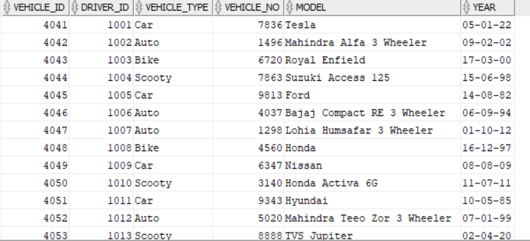

**Inserting data into Feedback table:**



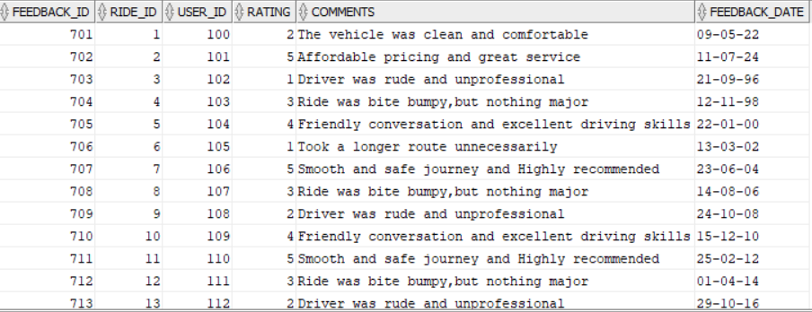

**Alter, Update the records:**

